**Money Tracker webapp**

**Technology for frontend**

* HTML
* CSS

**Technology for backend**

* NodeJS

**Technology for Database**

* MongoDB

**Landing page**

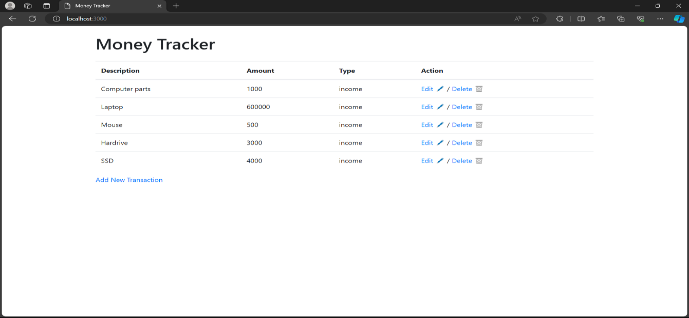

**Add Transaction page**

* Description

purpose of investment

* Amount

amount spends for the purpose

* Type

you have incomed the amount or invested

* Add transaction

click on transaction to add the inputted transaction data to the database

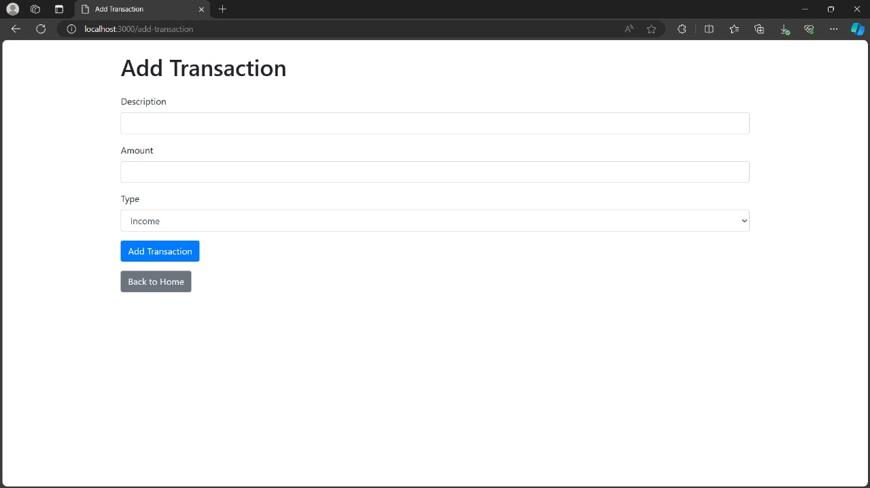

**Edit Transaction page**

* In edit transaction user can change or modify the description amount of investment
* After clicking on the save change update the data to the database

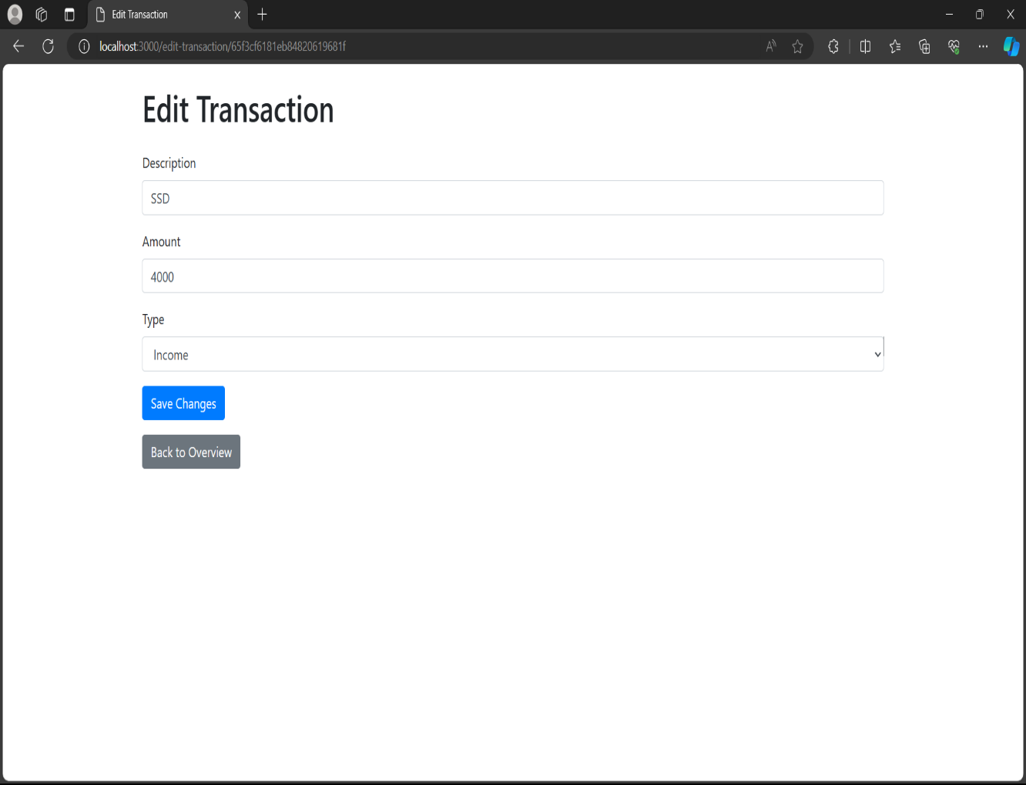

**Backend server**

**Dependence for running the application**

* Nodemon 3.1.0
* ejs 3.1.9
* mongoose 8.2.1
* Body-parser 3.1.0

**Commands for running the web application**

* To initialisation the Nodejs package

$ - npm init

* To install the dependencies

$ - npm install express mangoose body-parser ejs nodemon

* To run the server

$ - node server.js

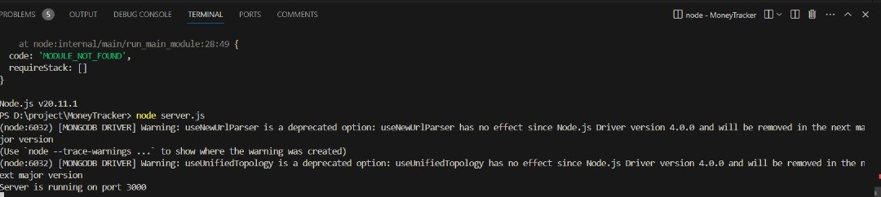

* Server start hosting the web page in local host port number (https://localhost:3000) Then in the web browser we can see the web page in given url.

**Database**

**Connection to the MongoDB**

* For connection to database (mangodb://localhost:27017/transactions)
* 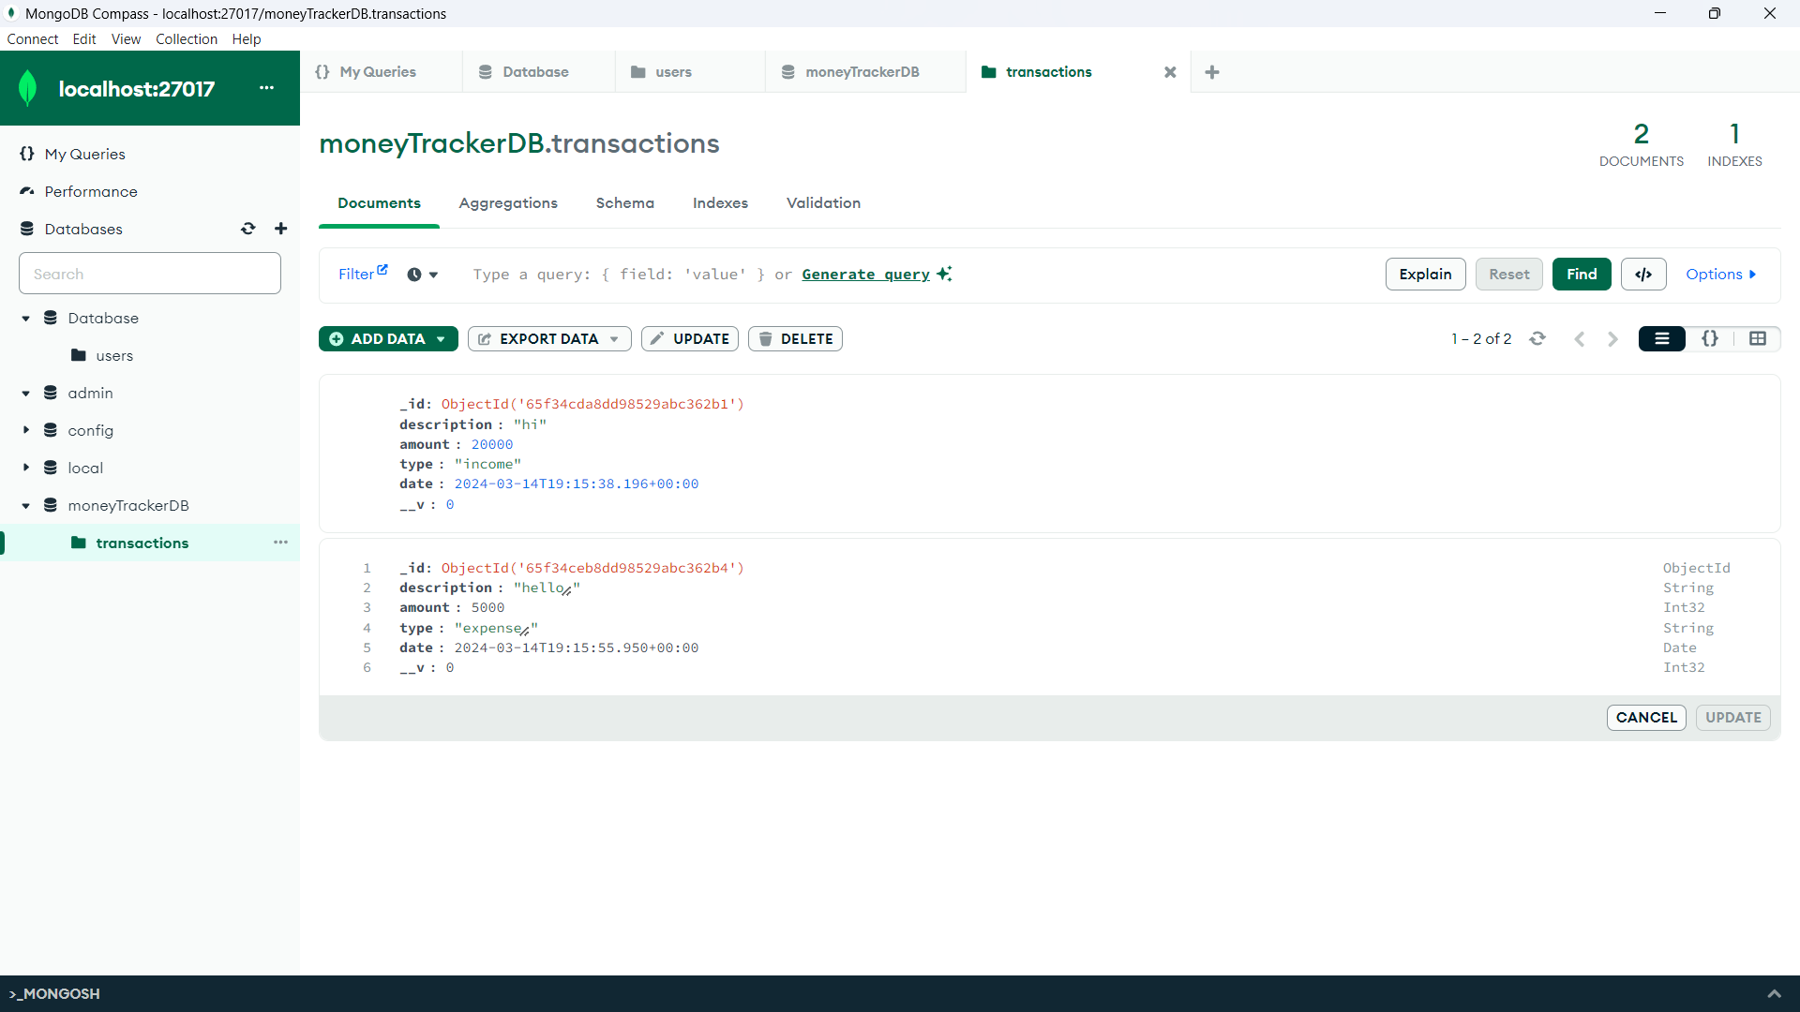After inserting the transactions to the frontend page, it will store the data in the bellow database file.

**Conclusion**

* after starting the server in the port number 3000 .in the browser

URL ->(https://localhost:3000) our frontend page will be displayed. Then the inserted transaction will save in our mongoDB database(mangodb://localhost:27017/transactions) and it will update the transaction after all you edit your transaction